**CHAPTER 1**

1. **INTRODUCTION**

**1.1 EXISTING SYSTEM**

The existing Open auction system is managed manually. In this system before the day of auction, the venue and the items on auction are announced through newspaper. Those who wish to take part in the auction have to arrive at the venue on that day on time. Then each people have to bid manually according to their wish. This conventional method most of the times prevent aspiring bidders from participating in the bidding process. Another headache of the old system is to visit the auction place due to some people inconvenience they may not be able to take part in the auction process. And this system has to wait for all the bidders’ arrival and then start the auction process and they are manually recording each person’s bid and it is time consuming one.

**1.2 SYSTEM STUDY**

The online auction system is a place for buyers and sellers to come together and trade almost anything. The system consists of web-portal where each user should register into the system by providing their details. The registration process is validated to check whether the user already exist or not. Without this confirmation, a user cannot access the functionality of the portal. The user has to login to the system and use web portal functionalities. The user can able to edit his profile, put a product for sale, search product based on the category and buy the product, give feedback about the auction. The users cannot place bids when the auction interval (start - end period) ends, but. Moreover, administrators have the possibility to view the registered users, items and to view the bidding status for all the product based on the category given by the administrator. The system is realized with a 3-tier architecture. It consists of a relational database that store the information regarding items, users, auctions and categories of auction; an application server that cares about the business logic of the system and the presentation layer that consists in the web browser where users can interact with the system.

**1.2 OBJECTIVE**

The problem with open auction is that the participation of the general public is very limited. The aim of the project is to socialize the auction so that people from far & wide and even across the continent can participate in it. The "E-Auction" site is developed with a vision to wipe out the inherent problems of "Conventional Auction House". "E-Auction" is designed in such a way that it is as user friendly as possible. So any aspiring bidder or seller can visit the site and engage in bidding with least effort.

In this system, after successful login of user he can put a product for sale. We can able to bid these products by changing the price. Once the bid end date arrives, the user who has bid with large amount will take the product. The system provides Paperless Auction System, it’s accessible to everyone, at any time no matter where they are, Reliable user validation & checking.

**1.2 SCOPE**

E-Auction is an online auction web site aimed at taking the auction to the fingertips of aspiring bidders there by opening up the doors of the "OPEN Auction House' to a wider cross section of Art Lovers and Antique Collectors. This site also acts as an open forum where buyers and sellers can come together and exchange their products. The site makes sure that the sellers get a fair deal and buyers get a genuine product. This project contains the user and admin module; the user can be either seller or buyer. The seller can put their product for sales and view their product’s bidding status occasionally till their bidding end date. When the product’s bid date ends, the product is sold to the particular user whom bidding price is very high. The buyer can search for a product to buy based the category they click all the items in that category will be displayed with the last bid price. When the buyer clicks on the desired product it moves on to the bidding page where all the details like remaining number of days to end the bidding for that product, short description about the product will be displayed and the buyer can bid for the product it will updated as the last bid price of that product. The admin can login into the application and view the bidding status of all the products and user details can also be viewed.

Online application of the whole system helps easy access anywhere. The time taken for process completion is now largely reduced. After bidding the database is automatically updated to the last buyer’s bid price. The database is managed by MySQL, so data will be easily accessed and retrieved. Data cannot be viewed or edited by unauthorized personnel. So, this automated and computerized system is safe, fast and user friendly. The front end designed using java server page that is connected to the database using servlet.

The proposed System has a several advantages like Excludes noisy crowds like conventional system where users have to sit and bid, excludes general frustration that usually happens while bidding in conventional system, no schedule constraint that means bidder can bid anytime and from anywhere, the bidding can be made on a global level.

**CHAPTER 2**

**2. GENERAL DESCRIPTION**

**2.1 PRODUCT PERSPECTIVE**

The proposed computerized E-Auction site has made auction process simple. The only pre-condition is that the user must register and authenticate before he/she can take part in the bidding process. The system uses HTTP forms authentication which creates a session cookie for any signed in user. Throughout the span of the session the cookie remains valid until the user logs out.

The online auction system stores the following:

**User Details**

It includes user id, username, password, building number and street, city, state, Pin code, phone number, email id.

**Product Details**

It includes user id, product id, product name, short description, detailed description, category, starting price, bid end date, status, remaining number of days.

**2.2 USER CHARACTERISTICS**

**Admin**

Admin will maintain the user details, product details and bidding. He can able to view details of user, all the products that are listed in the auction system and the person who have bid for the product.

**User**

The user will register and login into the system. The seller will put his product for a sale. The buyer will able to search the required product based on category. If he needs that particular product, he has to bid the product.

* 1. **DESIGN AND IMPLEMENTATION CONSTRAINTS**
* Only the registered and verified users can access the system.
* Apache Tomcat 7.0 Web Server is used. The request and responses are carried out in an effective manner by the server.
* User can bid for the product under auction before the end date.
* The bidding will be noticed by the admin.

**CHAPTER 3**

**3. REQUIREMENTS**

**3.1 FUNCTIONAL REQUIREMENTS**

**3.1.1 User Module**

Login/User Registration - Those who wish to take part in bidding or sell products at the site have to register at the site as seller or buyer. Only authenticated users can take part in selling or in bidding. The system automatically rejects un-authenticated users who try to bid or sell at the site.

Product Registration- This module is for presenting items for bidding. Only those who have registered and authenticated as sellers can place their articles for bidding. The Module collects information like Product Name, Product Details, Starting Bid amount, Incremental value etc. The system automatically inputs the closing date.

Bidding Module - The module is for bidding on any selected item. The bidder has to authenticate before participating in bidding. The system checks whether the incremental amount entered by the bidder is more than the incremental minimum set during the product registration time. The system places the record in the bid history against the bidder account.

My Auction - This page is an interface for both buyer and seller. Buyer can see the profile of the bidding history of items which are still open on which he/she has already bided. Similarly, the seller can see the progress of bidding on articles he/she has placed for bidding.

Feedback - The purpose of the page is to send messages/comments to the web administrator and edit user profile.

**3.1.2 Admin Module**

Admin Login – Admin can login to system and view products as well as feedback. Admin will maintain the user details, product details and bidding. He can able to view details of user, all the products that are listed in the auction system and the person who have bid for the product.

**3.2 NON-FUNCTIONAL REQUIREMENTS**

**3.2.1 Error Handling**

* E-Auction product shall handle expected and non-expected errors in ways that prevent loss in information.

**3.2.2 Performance Requirements**

* The system accommodates high number of products and their prices.
* Responses to view information shall take no longer than 5 seconds to appear on the screen.

**3.2.3 Safety Requirements**

* Maintainability
* Reliability.

**3.2.4 Security Requirements**

* System will use secured database.
* Product prices are updated only with user’s knowledge.

**3.3 USER INTERFACE**

**3.3.1 Hardware Requirements**

Hard disk: 250 GB and above

RAM: 2 GB and above

Processor: i3 and above

**3.3.2 Software Requirements**

Operating system: windows 7 and above

Web server: APACHE TOMCAT-8

RDBMS: MySQL

**3.3.3 Technologies Used**

**JSP**

Java Server Pages (JSP) is a Java standard technology that enables you to write dynamic, data-driven pages for your Java web applications. JSP is built on top of the Java Servlet specification. The two technologies typically work together, especially in older Java web applications. From a coding perspective, the most obvious difference between them is that with servlets you write Java code and then embed client-side markup (like HTML) into that code, whereas with JSP you start with the client-side script or markup, then embed JSP tags to connect your page to the Java backend.

**SERVLET**

A **servlet** is a Java programming language class that is used to extend the capabilities of servers that host applications accessed by means of a request-response programming model. Although servlets can respond to any type of request, they are commonly used to extend the applications hosted by web servers. For such applications, Java Servlet technology defines HTTP-specific servlet classes.

**BOOTSTRAP**

Bootstrap is the most popular HTML, CSS and JavaScript framework for developing a responsive and mobile friendly website. It is absolutely free to download and use. It is a front-end framework used for easier and faster web development. It includes HTML and CSS based design templates for typography, forms, buttons, tables, navigation, modals, image carousels and many others. It can also use JavaScript plug-ins. It facilitates you to create responsive designs. It is very easy to use. Anybody having basic knowledge of HTML and CSS can use Bootstrap. It facilitates users to develop a responsive website. It is compatible on most of browsers like Chrome, Firefox, Internet Explorer, Safari and Opera etc.

**JQUERY**

jQuery is a fast, small, cross-platform and feature-rich JavaScript library. It is designed to simplify the client-side scripting of HTML. It makes things like HTML document traversal and manipulation, animation, event handling, and AJAX very simple with an easy-to-use API that works on a lot of different type of browser.

**CHAPTER 4**

**4. DETAILED DESIGN**

**4.1 ARCHITECTURAL DESIGN**

The architecture for any application is broken into three separate logical layers, each with a well - defined set of interfaces. The first tier is referred to as the presentation layer and typically consists of graphical user interface of some kind. The middle tier, or business layer, consists of application or business layer and the third layer- the data layer contains the data that is needed for the application. The middle tier is basically the code that the user calls upon to retrieve the desired data. The presentation layer then receives the data and formats it for display.

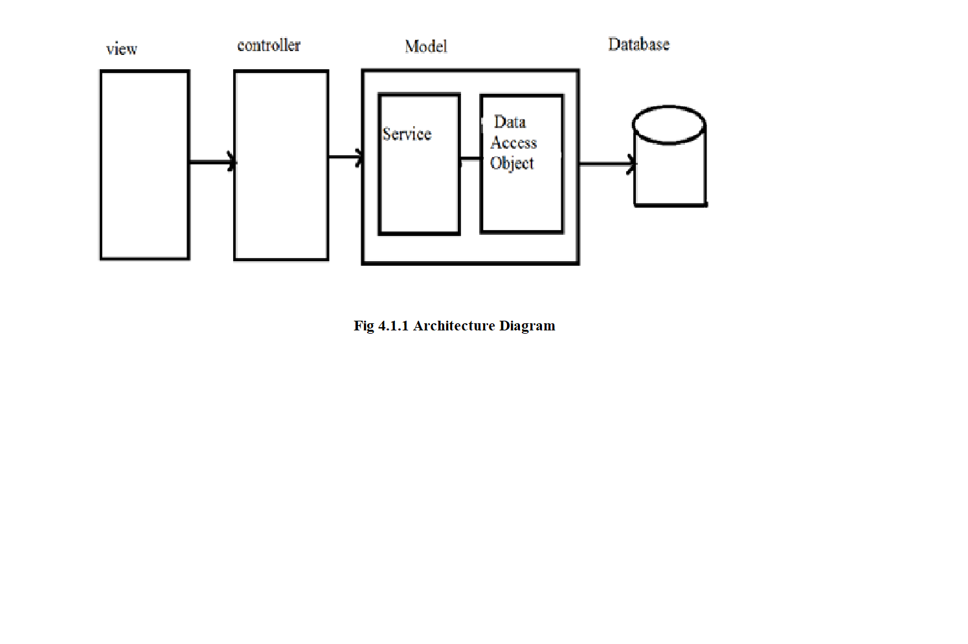

**4.2. USECASE DIAGRAM**

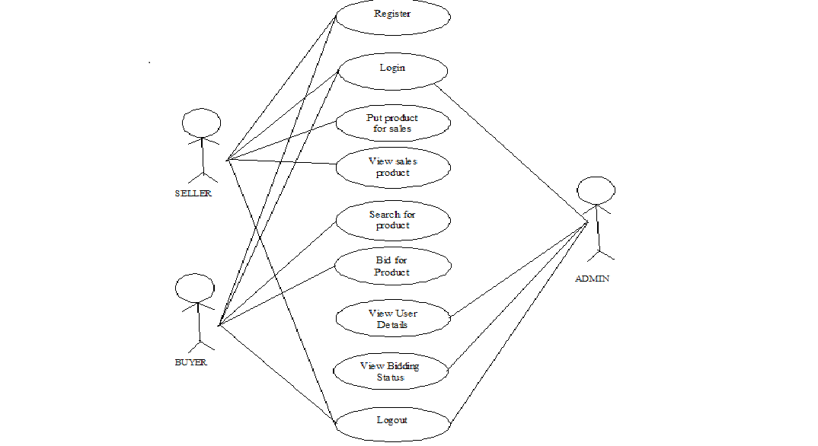

The users of online auction system are admin, buyers and sellers. The use cases are Login, put the product for sale, search for product, bid the product and view bidding status.

**Admin**

Admin will maintain the user details, product details and bidding. He can able to view details of user, all the products that are listed in the auction system and the person who have bid for the product.

**Buyers and Sellers**

The user will register and login into the system. The seller will put his product for a sale. The buyer will able to search the required product based on category. If he needs that particular product, he has to bid the product.

**REGISTER**

All the users must register with the required details to access the online bidding system.

**LOGIN**

The login page is where the user enter his username and password to enter into the system. If the username and match then it is redirected to next page or else an alert message is displayed.

**PUT FOR SALE**

This module is for presenting items for bidding. The Module collects information like Product Name, Product Details, Starting Bid amount, Incremental value etc. The system automatically inputs the closing date.

**SEARCH AND BID THE PRODUCT**

The module is for bidding on any selected item. The system checks whether the incremental amount entered by the bidder is more than the incremental minimum set during the product registration time.

**LOGOUT**

Logout is used to end the session.

**4.3. ACTIVITY DIAGRAM**

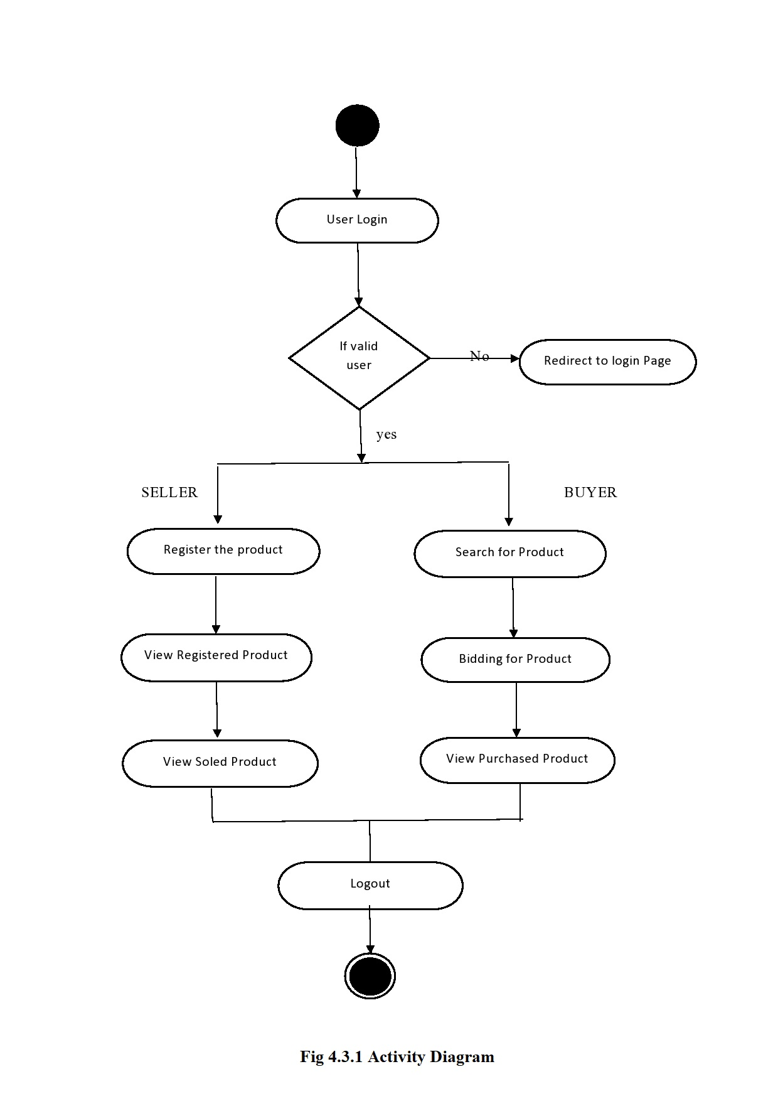

**4.4 DATABASE DESIGN**

The overall objective in the development of database technology has been to treat data as an organizational resource and as an integrated whole. DBMS allow data to be protected and organized separately from other resources. Database is an integrated collection of data. The most significant form of data as seen by the programmers is data as stored on the direct access storage devices. This is the difference between logical and physical data.

The proposed system stores the information relevant for processing in the MYSQL database. This database contains tables, where each table corresponds to one particular type of information. Each piece of information in table is called a field or column. A table also contains records, which is a set of fields. All records in a table have the same set of fields with different information. There are primary key fields that uniquely identify a record in a table. There are also fields that contain primary key from another table called foreign keys.

Database design is the organization of data according to database model. The database

design consists of database tables

1. User Details table
2. Put for Sales table
3. Bidding table
4. Feedback Table

**User Details**

User Details table consists of fields such as name, password, userid, phone number, address.

The details entered by the user is saved in database for any further updates or changes in their personal details can updated.

**Put for Sales table**

Put for Sales table consists of fields such as name, product name, product id, short description, detail description, starting bid price, bid end date.

The details entered by the seller is saved in database and it is updated when the bid price is given it is updated dynamically as the last bid price.

**Bidding table**

Bidding table consists of fields such as Bidder name, product id, bid price, bid date.

The details entered by the buyer is saved in database and it is updated when the bid price is given it is updated dynamically as the last bid price. Bidding details for all the products.

**Feedback Table**

Feedback table consists of fields such as Bidder User name, user id, phone number, feedback.

The details entered by the user is saved in database and it is viewed by the admin.

**4.5. OUTPUT DESIGN**

The output of the online auction system consists of the output in favor to the online sales and purchase of the products. The user personal details and the bidding status of all the products are viewed by the administrator

**CHAPTER 5**

**5. RESULTS AND DISCUSSIONS**

In business, there are situations were one get cheated by the people they trust. One way to safeguard their properties is to rely on technology. This project enables a person to have accurate results and to maintain each and every details securely. This work has been successfully completed and has been capable of maintaining trust between the users and the auction system and also, to restrict undesired bidding behaviors like shilling at runtime. Furthermore, it would allow all the parties in the bidding to have access to real-time reporting of events. The reports generated gives an outlook of a shop’s status and allows them to improve at tragic times. By automating by technology a lot of man power is reduced and allows them to concentrate on enhancing their economic growth of the company. Improving technology and implementing them can result in concise and prosperity in work environment.

This online system is used for customers to view all products that is up for auctioning and for the customers to upload their products for auctioning. The system has a platform for customers to post their bids and online advertising of products. The system gives bidders access to view auction details and detect shilling biddings. The system makes available the bidders history and maintain a robust database for managing the auction sales. It also maintains a database of bidder’s information.

**5.1 LOGIN PAGE**

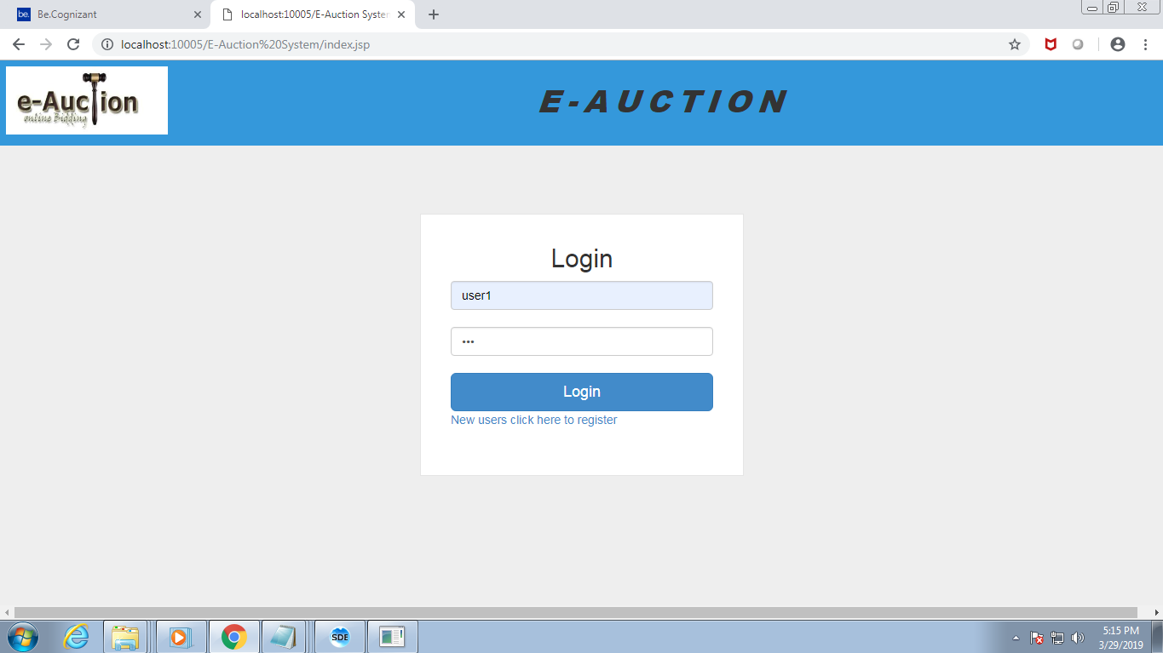

**Figure 5.1 1ogin Module**

User can login with his user id and password and check all the functionality from the menu. Refer screen print below for the User login.

**5.2 NEW USER REGISTRATION:**

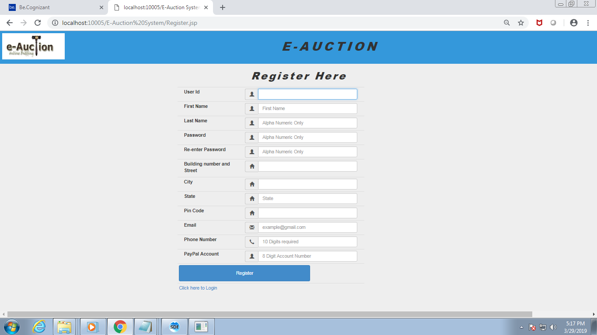

**Figure 5.2 New User Registration**

New user can be enrolled to the application by clicking **Register** link. User will be guided to fill registration form.

**5.3 MY PURCHASE PAGE**

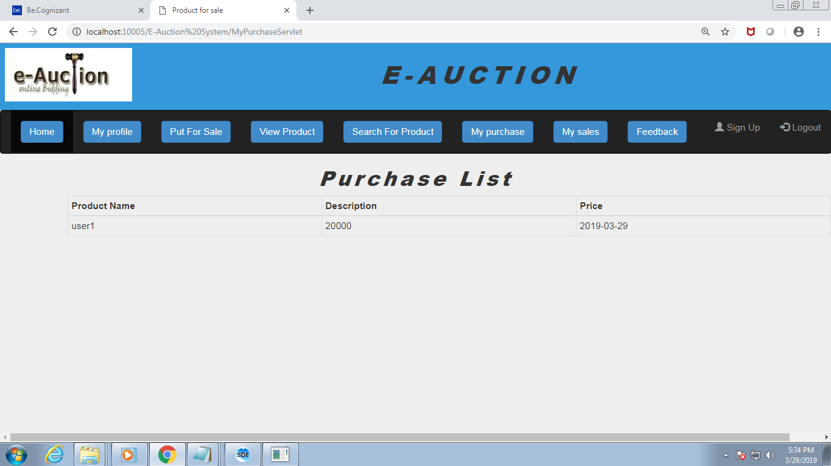

**Figure 5.3 Purchase page**

This module helps the user in viewing their products that are sold to other bidders and the products that they have bought in auction.

**5.4 MY SALES PAGE**

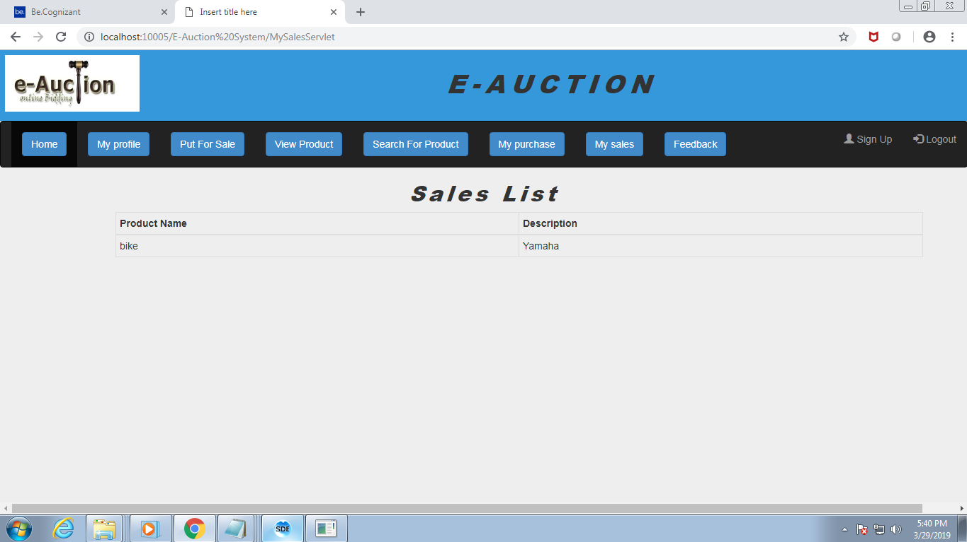

**Figure 5.4 Sales page**

This module helps the user in viewing their products that are displayed for sale. All the products related to that particular user is displayed.

**5.5 PUT FOR SALE:**

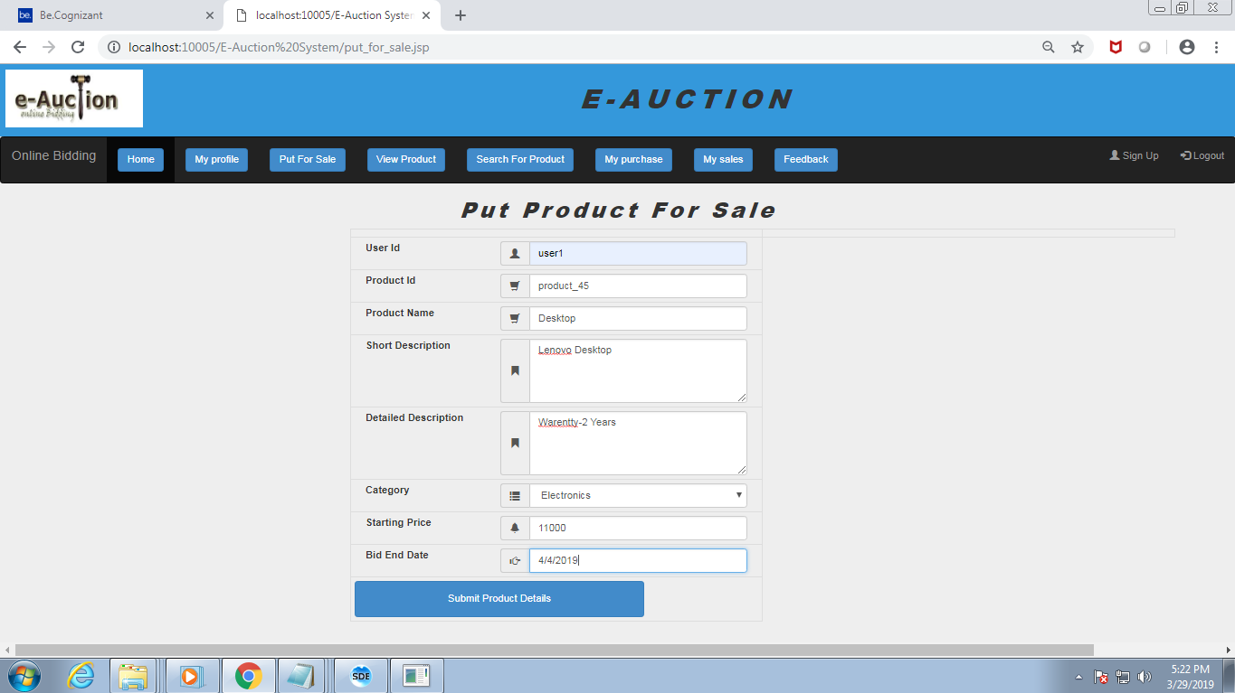

**Figure 5.5 Put product for sale page**

The user can put their product for sale using this page. He can register the product with necessary details.

**5.6 SEARCH PRODUCT:**

.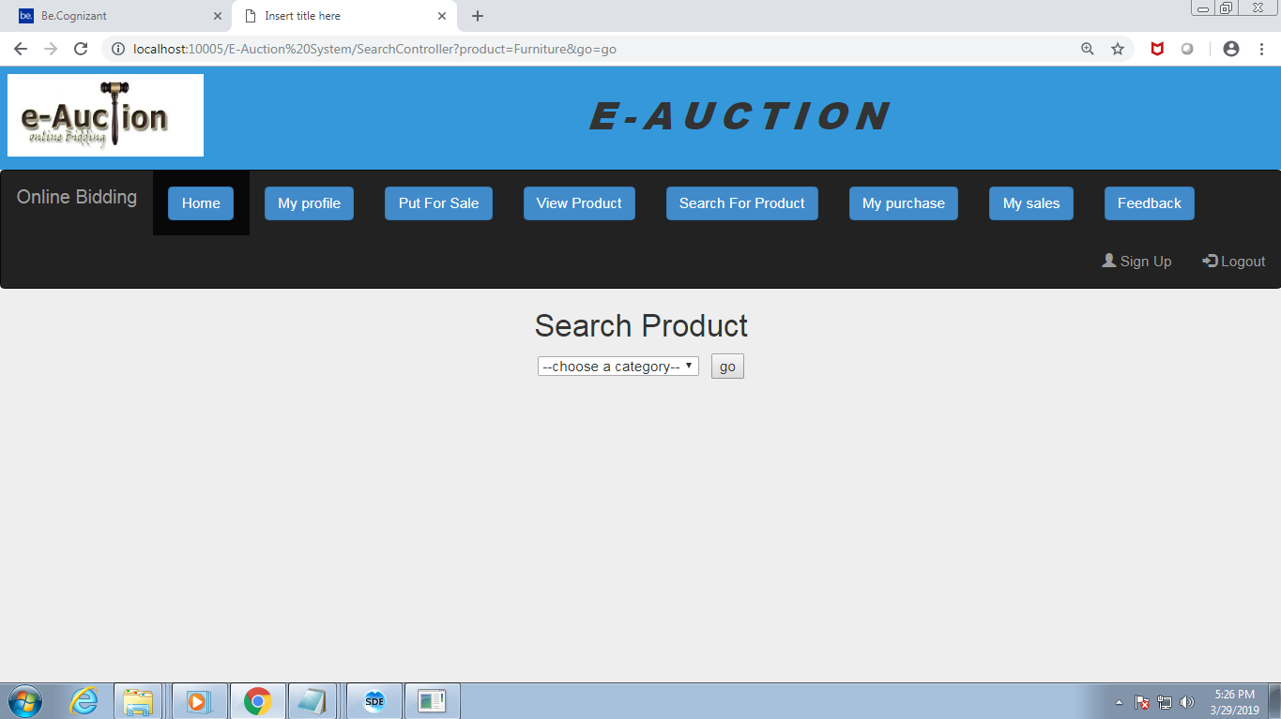

**Figure 5.6. Search page**

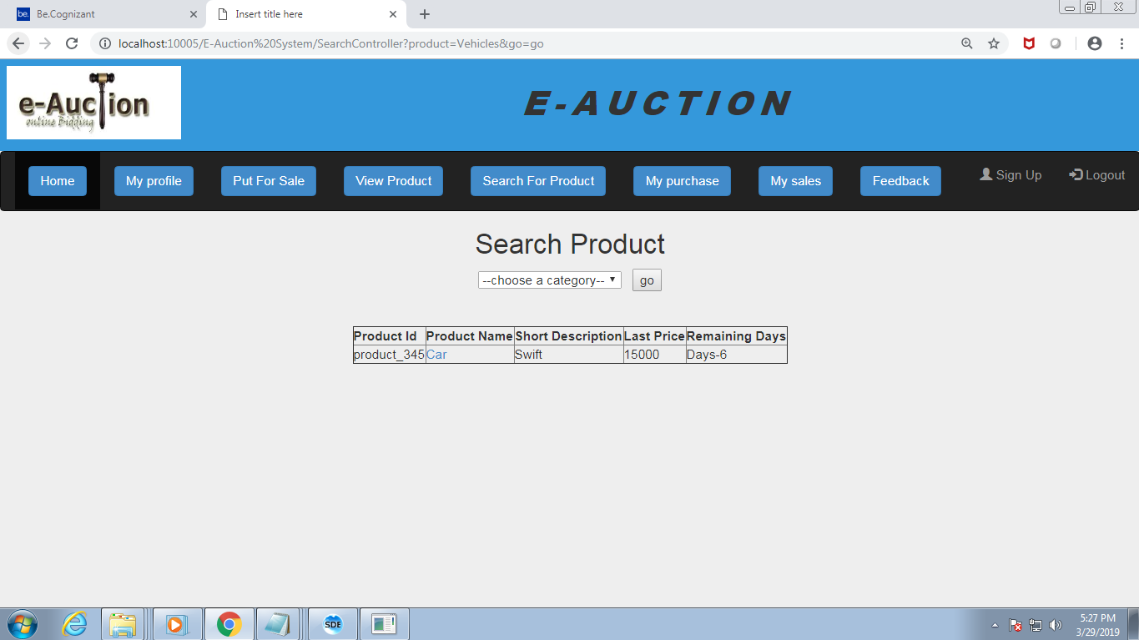

**Figure 5.7 Search Page**

**5.8 BIDDING PAGE**

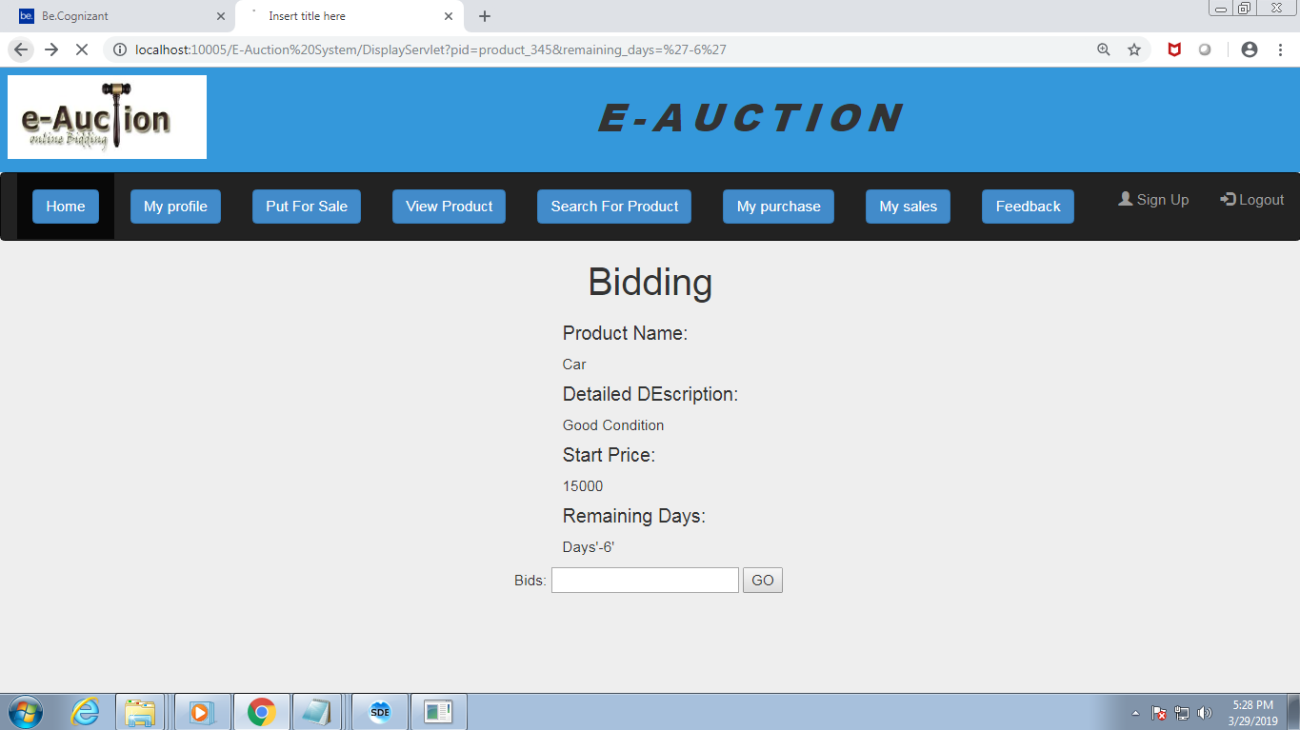

**Figure 5.8 Bidding Page**

This is the module where multiple users bid for a product and the product is sold for the person who quotes for the highest rate within the end date.

**5.9 FEEDBACK PAGE**

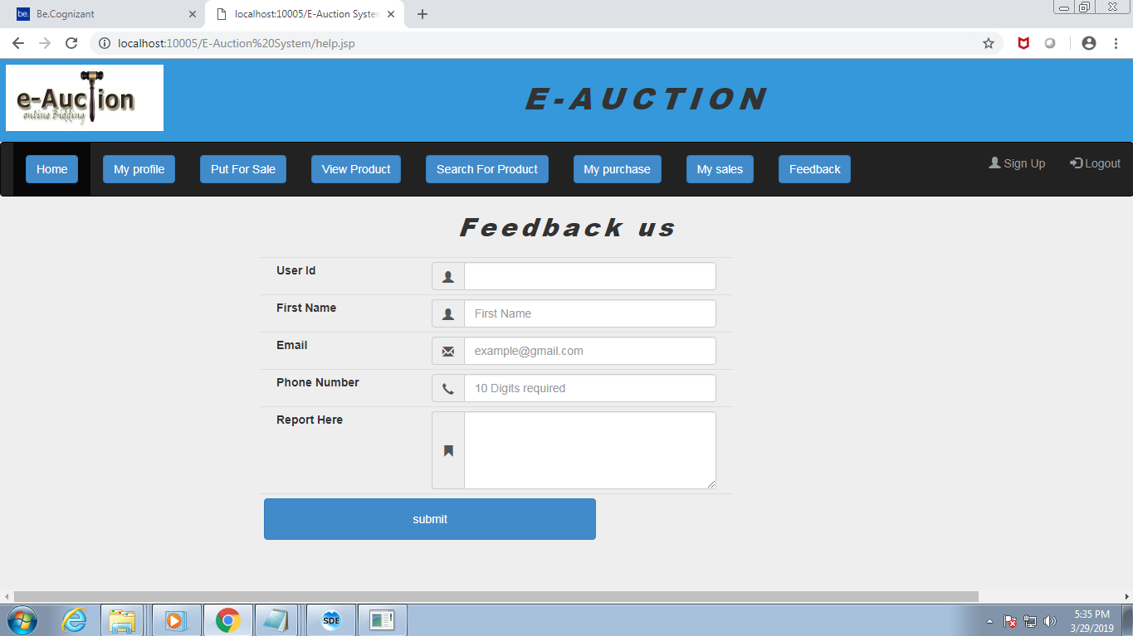

**Figure 5.9 Feedback Page**

**5.10 VIEW USERS PAGE**

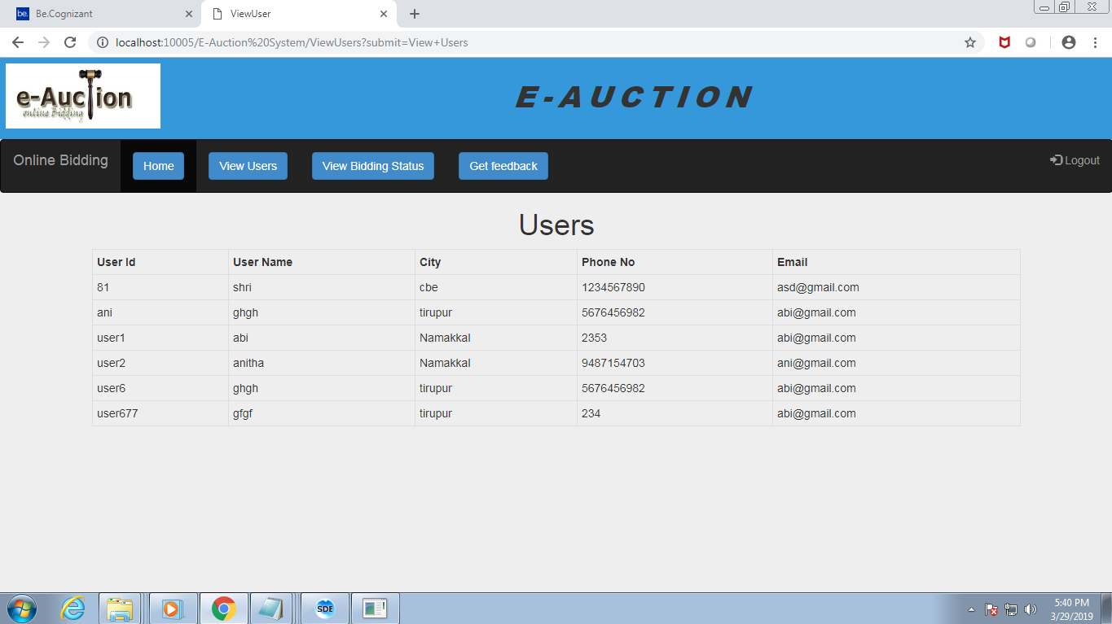

**5.10 View Users Page**

**5.11 VIEW BIDDING STATUS PAGE**

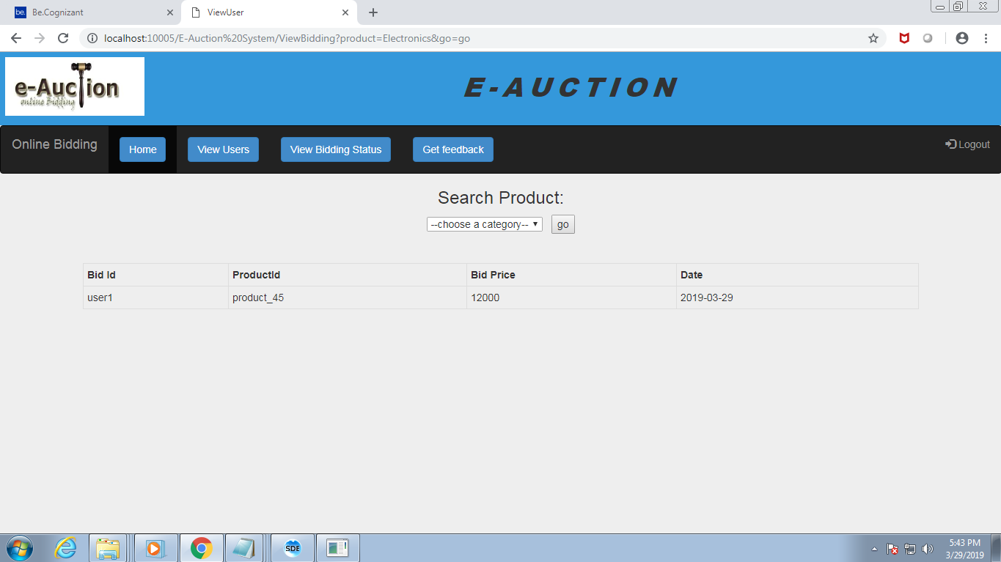

**Figure 5.11 View Bidding Status Page**

**CHAPTER 6**

**6. TESTING**

**6.1. UNIT TESTING**

A Unit corresponds to a screen /form in the package. Unit testing focuses on verification of the corresponding class or Screen. This testing includes testing of control paths, interfaces, local data structures, logical decisions, boundary conditions, and error handling. Unit testing may use Test Drivers, which are control programs to co-ordinate test case inputs and outputs, and Test stubs, which replace low-level modules. A stub is a dummy subprogram.

**6.2. REGRESSION TESTING**

Each modification in software impacts unmodified areas, which results serious injuries to that software. So the process of re-testing for rectification of errors due to modification is known as regression testing.

**Installation and Delivery:**

Installation and Delivery is the process of delivering the developed and tested software to the customer. Refer the support procedures

**Acceptance and Project Closure:**

Acceptance is the part of the project by which the customer accepts the product. This will be done as per the Project Closure, once the customer accepts the product; closure of the project is started. This includes metrics collection, PCD, etc.

**6.3 VALIDATION**

Validation refers to the process of using the new software for the developed system in a live environment i.e., new software inside the organization, in order to find out the errors. This application is validated using jQuery validation. The validation phase reveals the failures and the bugs in the developed system. It will be come to know about the practical difficulties the system faces when operated in the true environment.

By testing the code of the implemented software, the logic of the program can be examined. A specification test is conducted to check whether the specifications stating the program are performing under various conditions. Apart from these tests, there are some special tests conducted which are given below:

Peak Load Tests: This determines whether the new system will handle the volume of activities when the system is at the peak of its processing demand. The test has revealed that the new software for the agency is capable of handling the demands at the peak time.

Storage Testing: This determines the capacity of the new system to store transaction data on a disk or on other files. The proposed software has the required storage space available, because of the use of a number of hard disks.

Performance Time Testing: This test determines the length of the time used by the system to process transaction data.

**CHAPTER 7**

**7. CONCLUSION AND FUTURE WORK**

In this project, we addressed the problem of erroneous calculations in purchase and sales account of a retail store. One problem is the existing work was, human errors and accurate results cannot be computed due to lack of knowledge at some unintentional cases. Thus our work provided an optimal solution that can provide a platform to proceed calculations accurately which was integrated in a desktop based application. When this system proves to be flexible to the users and achieves to be user friendly then it can go through a series of advance steps that might be handy to use for all the users. The future work may comprise of paying bill through online transactions and paying taxes being automated. If more numbers are benefited, then the details can be stored in cloud and lead to peer-to-peer interactions. This system can be modified in a further for audit computation and online transactions can be added if it is to be implemented as web application. Many different adaptations, test and experiments have been left for the future due to lack of time. Future work concerns deeper analysis of particular mechanism, new proposals to try different methods or simply curiosity. For further better improvements it relies on user’s needs and technical advisor’s optimized level of thinking.

**CHAPTER 8**

**8. REFRENCES**

**WEB REFERENCES**

<http://www.roseindia.net/jsp/jsp.htm>

<http://java.sun.com/javaee/5/docs/tutorial/doc/bnafd.html>

<http://www.exforsys.com/tutorials/jsp.html>

[http://www.jmarshall.com](http://www.jmarshall.com/)

[http://www.javaworld.com](http://www.javaworld.com/)

<http://java.sun.com/products/servlet/articles/tutorial/>

<http://www.coreservlets.com/>

[http://msdn.microsoft.com](http://msdn.microsoft.com/)

[http://www.devx.com](http://www.devx.com/)

<http://en.wikipedia.org/wiki>

[http://websiteowner.info](http://websiteowner.info/)

[http://www.w3.org](http://www.w3.org/)

<http://java.sun.com/j2ee/1.4/docs/api/javax/servlet/http/HttpServlet.html>